**Sina Nejati**

[**nejat001@cougars.csusm.edu**](mailto:nejat001@cougars.csusm.edu)

**CS 590 – Artificial Intelligence**

**Prof. Guillen**

**10/17/2011**

**Cannibals and Missionaries design document**

I created a program in Java to solve the missionaries and cannibals problem.

Main Classes:

Main:

The main class that provides either an application interface (text

Only) or an applet interface (nice animating GUI). Only the application interface will be described in this document.

Functions: None

Node:

The State class holds one possible state of the problem, Including the

Location of missionaries and cannibals and also the boat placement. Functions:

Validate:

Checks node state to see if it is a valid state based on the problem description.

Check:

Checks if a node is present in a given array.

Expand:

Expands a node and creates the successors.

Search:

Calls the expand on all the nodes of the array.

Find path:

Find outs the parent of a node, replaces the node with the parent and calls the function again until the parent node is null.

Design diagram:

Main ---Uses-🡪[ expand & Search]

Search –Uses🡪 [expand]

Expand—Uses🡪[Validate,check,findpath]

State Diagram:

With invalid moves and repeated states removed.

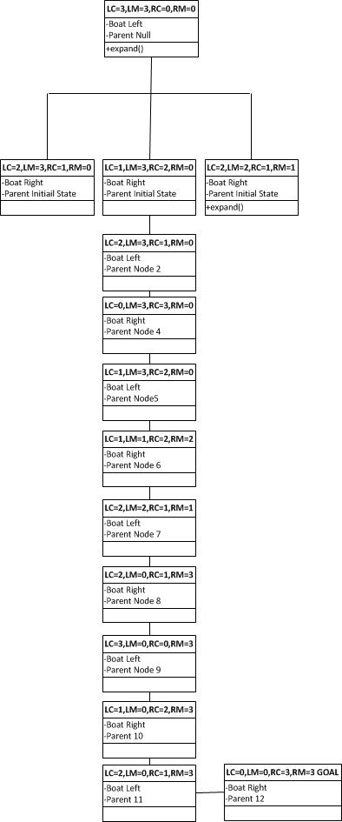

Why people have hard time solving this possible?

* + They do not keep track of the moves they made, So they end up repeating steps and getting into loops
  + They try to move them randomly without checking if it’s a valid state.